▶ Our Project Documentataion◀

|  |  |
| --- | --- |
| Project Name | Rover |
| Date | 19 October 2023 |
| Topic | Space exploration |
| Project Overview | We are going to make the Rover. In the high Quality sensor upgraded in it.  &. It employs a rocker-bogie suspension which allows the rover to run smoothly. |
| Class | 9th F |
| Group Members | 1. Shoryan Chahar 2. Aditya 3. Ayush 4. Yuvraj 5. Viraj 6. Shreyash |
| Budget | ₹3000 |

* Project Name :- Rover

* Topic :- Space Exploration
* Overview:-

Let’s take a look at the main features of this rover. It employs a rocker-bogie suspension which allows the rover to run smoothly on uneven terrain and climb, such as rocks, that are up to twice the wheel’s diameter in size while keeping all six wheels in contact with the ground all time. Each wheel has independent DC motor which drives the rover forward or backward.

The four corner wheels have individual steering servo motors. In order to efficiently steer the rover and avoid tire slipping when driving around a curve, we are implementing the Ackermann steering geometry. With this geometry we can calculate the speed and angle of each wheel depending on the turning radius. This means that, when turning, the inner steering wheels will have a greater angle compared to the outer wheels. At the same time, the inner wheels will have slower speeds compared to the outer wheels. For controlling the rover, we are using a cheap commercial RC Transmitter which sends commands to the rover. At the rover we have suitable RC receiver which receives the commands and sends them to an chip. The rover also features an camera located in the cameras unit. It is controlled using a stepper and a servo motor and we are going to receiving the real-time video on a Smartphone by connecting with the Bluetooth .& the working arm.

* Material Required:-
* Plastice body
* Sensor
* Camera
* Chip
* Speaker
* RC Transmitter
* Servo moter
* Moter
* Wheels
* Gear DC Motor
* RGB Led Lights
* Cables/Wires
* Expansions Boards
* Solor panel
* Batteries
* Light
* Pvc sheet
* Software Required for programming are :-
* Replit
* Python
* VS Codes
* Group Members :-
* Shoryan Chahar
* Viraj
* Aditya
* Yuvraj
* Shreyash
* Auysh
* So Are Budget is ₹ 3000
* Here are Some Example of our Projet :-

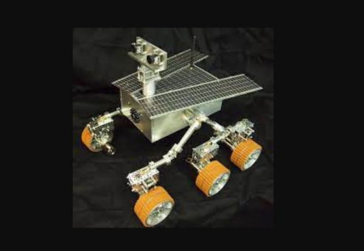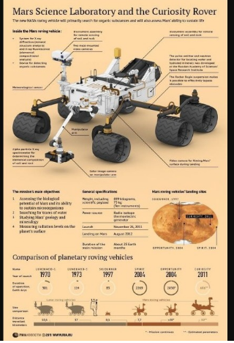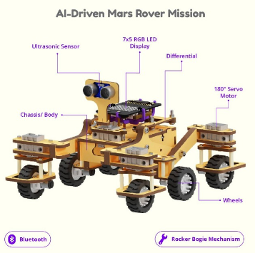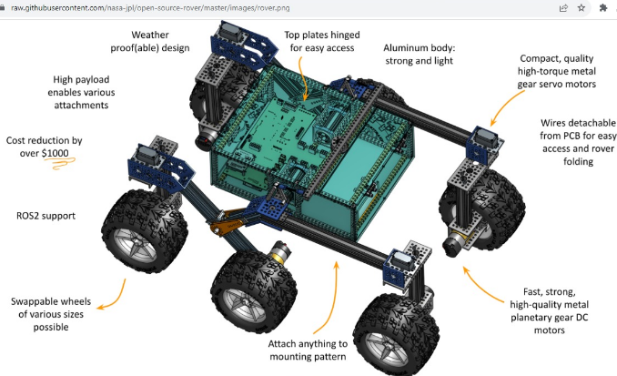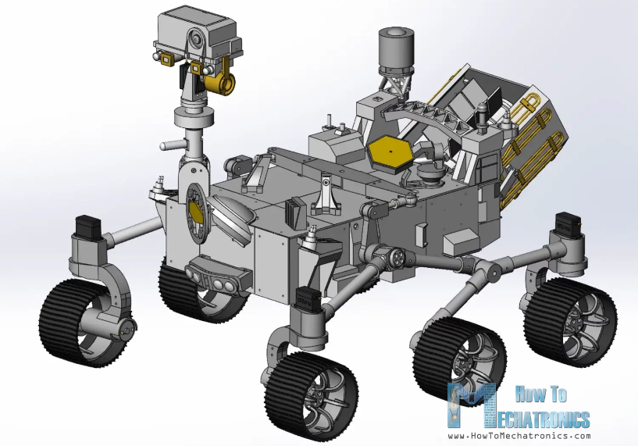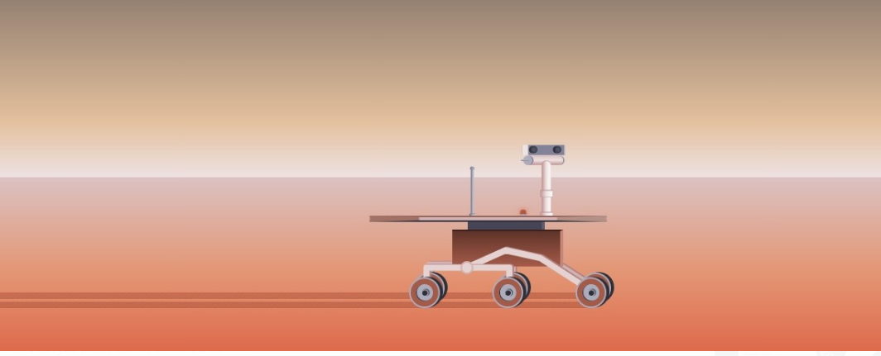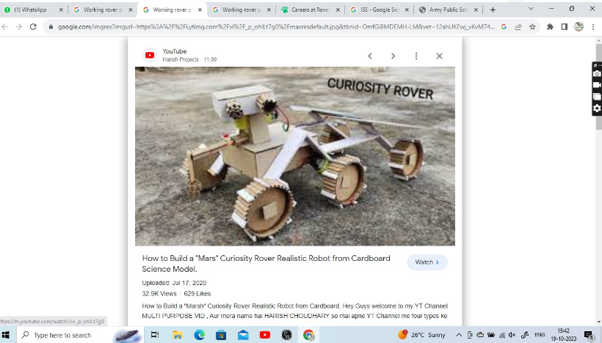 f  
  
  
  
  
  
  
  
  
  
  
  
  
  
Developed by Shoryan Chahar